World Cat Federation
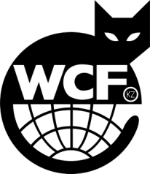
KAZAKHSTAN UNION of FELINOLOGISTS
KUF KZ 0233

The Republic of Kazakhstan, Almaty

phone: +7 701 783 56 05
Mailto: murlyka-kz@mail.ru
CERTIFICATE OF ACCESSORIES
(TRANSFER)

Issued __________________________________________________
that he is the owner of a cat

Name of cat ______________________________________________

Colour, cost tyre ____________________________________________________

Breed ________________________________________________

sex _________________________________________________

Date of Birth_______________________________________________

Certificate of inter Genealogy № ___________________________________________

President
“KUF KZ 0233”
cat fancier club Ordaliyeva S.S.

« »__________________ 20 г.

